WEEK 1
SESSION 1 - Introduction to Functional Programming Concepts
- JAVA LAMBDA EXPRESSIONS
PROGRAM
import java.util.*;

interface PerformOperation {
boolean check(int a);
}

public class Solution {

public static boolean checker(PerformOperation p, int num) {
return p.check(num);
}

public static PerformOperation isOdd() {
return new PerformOperation() {
public boolean check(int n) {
return n % 2 != 0;
}
};
}

public static PerformOperation isPrime() {
return new PerformOperation() {
public boolean check(int n) {
if (n < 2) {
return false;
}

for (int i = 2; i * i <= n; i++) {
if (n % i == 0) {
return false;
}
}

return true;
}
};
}

public static PerformOperation isPalindrome() {
return new PerformOperation() {
public boolean check(int n) {
int original = n;
int reverse = 0;

while (n > 0) {
reverse = reverse * 10 + n % 10;
n = n / 10;
}

return original == reverse;
}
};
}

public static void main(String[] args) {
Scanner sc = new Scanner(System.in);

int t = sc.nextInt();

while (t-- > 0) {
int condition = sc.nextInt();
int num = sc.nextInt();

if (condition == 1) {
System.out.println(checker(isOdd(), num) ? "ODD" : "EVEN");
}
else if (condition == 2) {
System.out.println(checker(isPrime(), num) ? "PRIME" : "COMPOSITE");
}
else if (condition == 3) {
System.out.println(checker(isPalindrome(), num) ? "PALINDROME" : "NOT PALINDROME");
}
}

sc.close();
}
}

OUTPUT
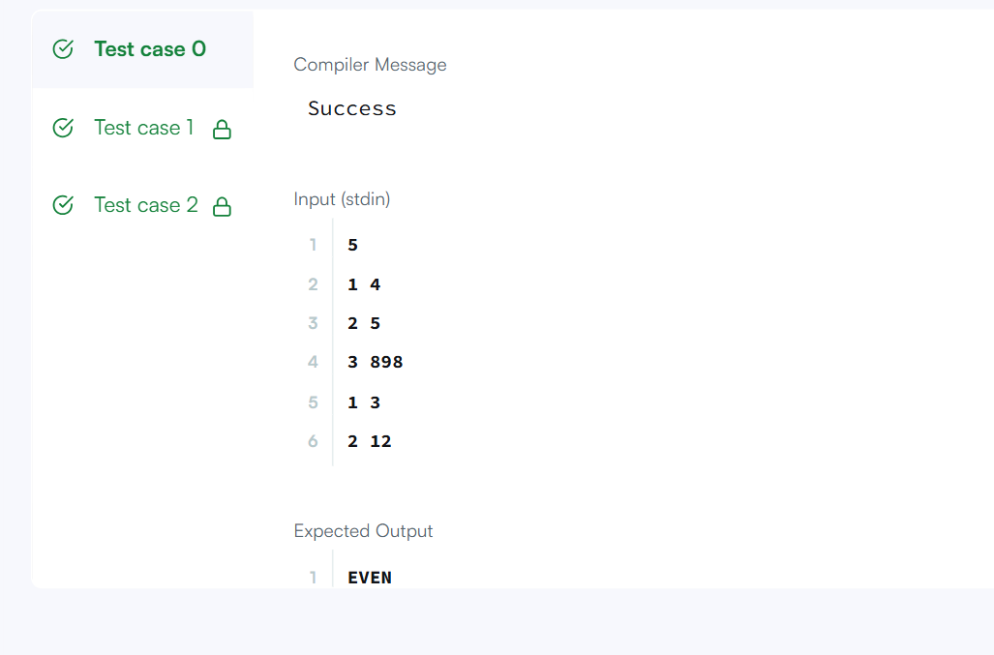
- JAVA COMPARATOR
PROGRAM
import java.util.*;

// Write your Checker class here

class Player{
String name;
int score;

Player(String name, int score){
this.name = name;
this.score = score;
}
}

class Solution {

public static void main(String[] args) {
Scanner scan = new Scanner(System.in);
int n = scan.nextInt();

Player[] player = new Player[n];
Checker checker = new Checker();

for(int i = 0; i < n; i++){
player[i] = new Player(scan.next(), scan.nextInt());
}
scan.close();

Arrays.sort(player, checker);
for(int i = 0; i < player.length; i++){
System.out.printf("%s %s\n", player[i].name, player[i].score);
}
}
}
OUTPUT

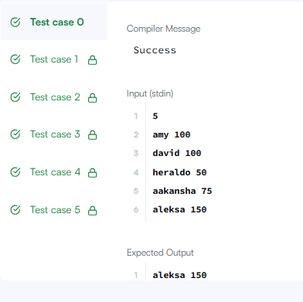

SESSION 2 - Lambda Expressions
- JAVA SORT
PROGRAM
import java.util.*;

class Student{
private int id;
private String fname;
private double cgpa;
public Student(int id, String fname, double cgpa) {
super();
this.id = id;
this.fname = fname;
this.cgpa = cgpa;
}
public int getId() {
return id;
}
public String getFname() {
return fname;
}
public double getCgpa() {
return cgpa;
}
}

//Complete the code
public class Solution
{
public static void main(String[] args){
Scanner in = new Scanner(System.in);
int testCases = Integer.parseInt(in.nextLine());

List<Student> studentList = new ArrayList<Student>();
while(testCases>0){
int id = in.nextInt();
String fname = in.next();
double cgpa = in.nextDouble();

Student st = new Student(id, fname, cgpa);
studentList.add(st);

testCases--;
}

for(Student st: studentList){
System.out.println(st.getFname());
}
}
}
OUTPUT
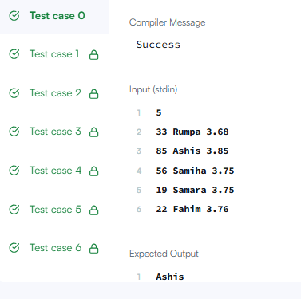

SESSION 3 - Anonymous Functions & Functional Interfaces
SORTING COMPARATOR
PROGRAM
import java.util.*;

class Player {
String name;
int score;

Player(String name, int score) {
this.name = name;
this.score = score;
}
}

class Checker implements Comparator<Player> {
// complete this method
public int compare(Player a, Player b) {
return Comparator.comparing((Player p) -> p.score, Comparator.reverseOrder())
.thenComparing(p -> p.name)
.compare(a, b);

}
}

public class Solution {

public static void main(String[] args) {
Scanner scan = new Scanner(System.in);
int n = scan.nextInt();

Player[] player = new Player[n];
Checker checker = new Checker();

for(int i = 0; i < n; i++){
player[i] = new Player(scan.next(), scan.nextInt());
}
scan.close();

Arrays.sort(player, checker);
for(int i = 0; i < player.length; i++){
System.out.printf("%s %s\n", player[i].name, player[i].score);
}
}
}
OUTPUT
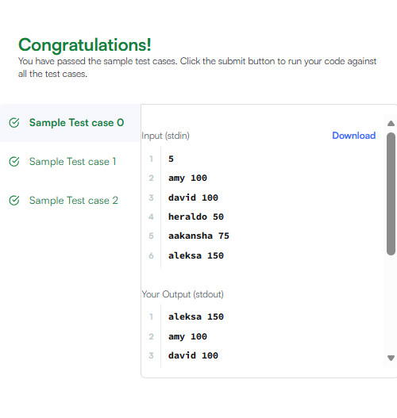

SESSION 4- Higher-Order Functions
- Running Sum of 1D Array
PROGRAMM
- class Solution {
- public int[] runningSum(int[] nums) {
- for (int i = 1; i < nums.length; i++) {
- nums[i] += nums[i - 1];
- }
- return nums;
- }
- }

OUTPUT
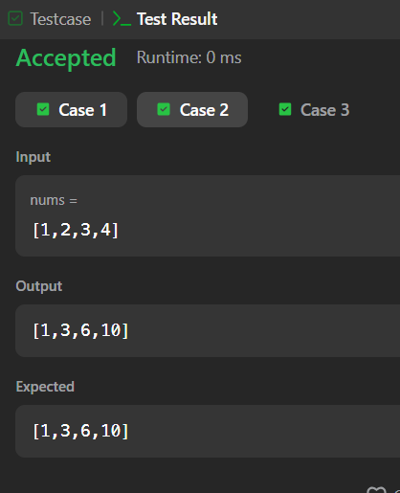
- Richest Customer Wealth
PROGRAM
class Solution {
public int maximumWealth(int[][] accounts) {
int maxWealth = 0;

for (int i = 0; i < accounts.length; i++) {
int wealth = 0;

for (int j = 0; j < accounts[i].length; j++) {
wealth += accounts[i][j];
}

maxWealth = Math.max(maxWealth, wealth);
}

return maxWealth;
}
}
OUTPUT
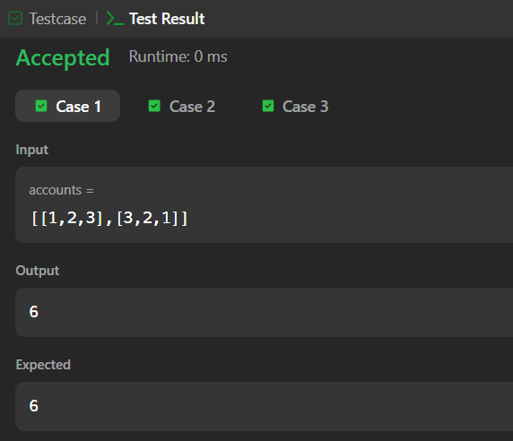

Session 5 Higher-Order Functions
- Squares of a Sorted Array
PROGRAM
class Solution {
public int[] sortedSquares(int[] nums) {
int n = nums.length;
int[] result = new int[n];

int left = 0;
int right = n - 1;
int index = n - 1;

while (left <= right) {
if (Math.abs(nums[left]) > Math.abs(nums[right])) {
result[index] = nums[left] * nums[left];
left++;
} else {
result[index] = nums[right] * nums[right];
right--;
}
index--;
}

return result;
}
}
OUTPUT

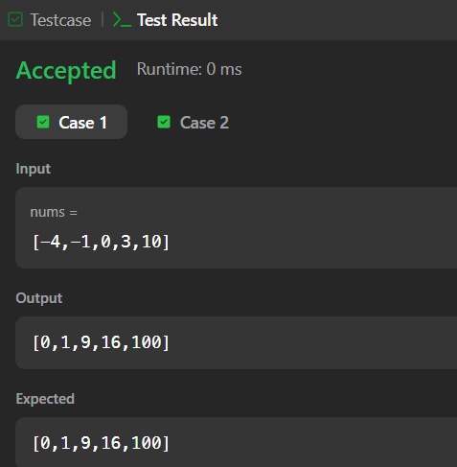
- Find Pivot Index
PROGRAM
class Solution {
public int pivotIndex(int[] nums) {
int totalSum = 0;
int leftSum = 0;

// Step 1: Calculate the total sum of all elements in the array
for (int num : nums) {
totalSum += num;
}

// Step 2: Iterate through the array to find the pivot index
for (int i = 0; i < nums.length; i++) {
// Right sum is calculated as: totalSum - leftSum - nums[i]
if (leftSum == totalSum - leftSum - nums[i]) {
return i; // Return the leftmost pivot index immediately
}
// Update the running left sum for the next index
leftSum += nums[i];
}

// Return -1 if no pivot index exists
return -1;
}
}

OUTPUT
